**Jellett, Mainie (Mary Harriet) 1897-1944**

Mainie Jellett was the most important of a remarkable generation of Anglo-Irish women artists studying in Paris after the First World War. She is credited with the introduction of modernist painting to Ireland. In 1921, Jellett and Evie Hone briefly studied with the Cubist painter André Lhote before persuading Albert Gleizes to accept them as pupils. Jellett and Hone soon became collaborators with Gleizes in the development of a late Cubist abstraction linked to a spiritual reality. Jellett’s painting *Decoration* wasexhibited at the Society of Dublin Painters in 1923. Combining interrelated planes of saturated colour with an underlying religious motif, it was greeted with suspicion and incomprehension by reviewers. Jellett and Hone regularly visited Gleizes in France and, in 1932, she became a part of the Abstraction – Création group. Mainie Jellett continued to exhibit in Dublin and actively championed the cause of modernist painting within the new Free State through her writings and lectures. She welcomed the wartime influx of artists such as the White Stag Group and was chairman of the first Irish Exhibition of Living Art although her final illness prevented her from exhibiting.

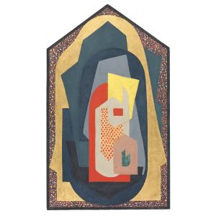

Mainie Jellett *Decoration* 1923 <http://onlinecollection.nationalgallery.ie/view/objects/asitem/Objects$004014105/0;jsessionid=1BE483CA18D57928F19B047CFC314648?t:state:flow=72f7318a-0ed1-422c-9871-7124f8793036>

Further Reading:

Arnold, B. (1991) *Mainie Jellett and the Modern Movement in Ireland,* New Haven and London: Yale University Press

Jellett, M. (1931/1958) ‘Modern Art and Some of its Aspects’ (date unknown), ‘Modern Art and its Relation to the Past’ in *Mainie Jellett: the Artist’s Vision* ed. Eileen McCarvill, Dundalk: Dun Dealgan Press

*Mainie Jellett 1897 -1994*, exhibition catalogue (1991), Dublin: Irish Museum of Modern Art

Kissane, S. ed. (2013) *Analysing Cubism,* Dublin: Irish Museum of Modern Art. Catalogue of exhibition featuring Jellett, Hone and other Irish artists who studied in Paris after the First World War